Comms toolkit: Introducing EOSC Ice Breakers: A dynamic tool for trainers in Open Science

News item

Developed by the EOSC Future project, ‘EOSC Ice Breakers’ are a valuable resource for trainers keen on diving deeper into topics related to the European Open Science Cloud (EOSC). Find out more about the discussion cards and how they can help you develop an Open Science learning path with your peers.

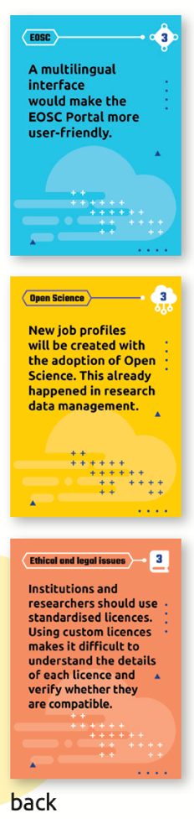
Innovative and engaging, EOSC Ice Breakers include a deck of 30 discussion cards: 22 statement (Q&A) cards and 8 mythbusting cards. The statement cards are colour-coded depending on level of difficulty and topic:

- Open Science
- EOSC
- Ethical & legal issues

Unsure how to get started? A set of playing instructions comes with the EOSC discussion card deck.

  - A card game based on Open Science principles
In essence, these discussion cards are an Open Educational Resource, underlining accessibility and freedom of use. Released under the Creative Commons Public Domain Dedication (CC0 1.0 Universal) licence, anyone can tailor the game to their specific requirements and enhance their utility.

Facilitating further customisation, the printable PDF file is complemented by editable design files compatible with Adobe InDesign. These design files include templates for blank cards, empowering users to craft additional cards or fine-tune existing ones, thereby amplifying the resource's versatility and relevance to diverse audiences.
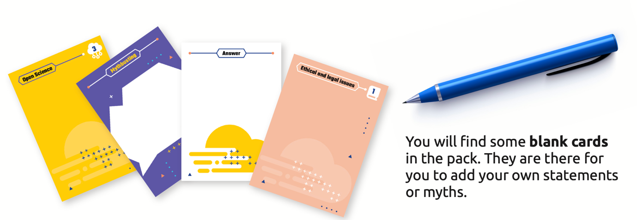

Not just for EOSC newbies

With its open-access approach and adaptable design, this resource aims to empower trainers and learners alike, fostering a deeper understanding of EOSC-related subjects and encouraging active participation in the discourse surrounding Open Science.

They are for anyone seeking to engage, educate and explore the world of EOSC and Open Science.

Check out the EOSC Ice Breakers and playing guidelines here.

Ready-made social media posts: Twitter/X & LinkedIn

Twitter/X

For the EOSC Future account
We’ve gamified #EOSC! EOSC Ice Breakers include 3️⃣0️⃣ discussion cards on
- Open Science
- EOSC
- Ethical & legal issues

Test your knowledge here: https://zenodo.org/records/10044731

For multiplier accounts

Need a tip on how to explain #EOSC?
@EOSCFuture has developed 3️⃣0️⃣ discussion cards to boost #OpenScience knowledge in an inclusive and interactive way.

➡️Check out EOSC Ice Breakers: https://zenodo.org/records/10044731

---------

Are you involved in #OpenScience?
Want to share your knowledge with your colleagues and students?
#EOSC Ice Breakers are here to help you build a learning path together with your peers! https://zenodo.org/records/10044731

----------

EOSC Ice Breakers: An innovative tool for trainers diving into #OpenScience! Developed as part of the @EOSCFuture project, these discussion cards offer a dynamic way to explore EOSC-related topics
♻️🔍 https://zenodo.org/records/10044731

LinkedIn

EOSC Future account

We’ve created an interactive tool to help trainers prepare activities and courses on #EOSC

➡️3️⃣0️⃣ discussion and mythbusting cards
➡️Covering Open Science, EOSC, Ethical & legal issues
➡️Customisable and ready-to-print cards

Check out EOSC Ice Breakers: https://zenodo.org/records/1004473

#EOSC #OpenScience #TrainTheTrainer

Multiplier accounts

EOSC Ice Breakers: A new resource for trainers diving into #OpenScience!

Developed as part of the @EOSC Future project, these discussion cards are:

✅Ready for print
✅Shareable online

Each deck contains blank cards and design files, so you can explore #EOSC-related topics and engage with a variety of audiences. 🔍🤝🔬

💡 Access the EOSC Ice Breakers here: https://zenodo.org/records/1004473

#EOSC #OpenScience #TrainTheTrainer

-------

Are you a trainer or researcher involved in #OpenScience and #FAIRdata management? Check out #EOSC Ice Breakers!

The @EOSCFuture project has developed 30 discussion cards:
➡️8 mythbusting cards
➡️22 statement (Q&A) cards
➡️Playing instructions

Find out more: https://zenodo.org/records/1004473

#EOSC #OpenScience #TrainTheTrainer

Email template

Subject: EOSC Ice Breakers cards - A dynamic tool for trainers & researchers in Open Science

Hello [ ],

We would like to share a new training resource for engaging, exploring and building a learning path on Open Science, developed by the H2020 EOSC Future project.

EOSC Ice Breakers comprise of 30 cards in total: 22 statement (Q&A) cards and 8 mythbusting cards.

The cards can be used to launch discussions and develop an understanding of the European Open Science Cloud. The content varies, depending on level of complexity and thematic focus:

- EOSC
- Open Science
- Ethical & legal issues

Following Open Science and FAIR principles, EOSC Ice Breakers are an Open Educational Resource, accessible and free to be used by all.

Try EOSC Ice Breakers out for yourself and share them with your colleagues: https://openplato.eu/blocks/catalog/detail.php?id=59

Kind regards,

